**Design Project 3**

**Part 2**

Member: Nguyễn Phú Quốc _ 2162502

Lê Thành Tài _ 2162496

Huỳnh Thái Trình _ 2183371

* + Describe who is the persona

**App: Show user where they can park their car**

Sara



Age: 28

Gender: female

Nationality: Indonesia

Location: Bekasi

Occupation: Photographer

She wants to find a parking slot easy

Katie



Age: 32

Gender: female

Nationality: US

Occupation: freelance

Every time she parks a car, it takes more than 30 minutes to find the parking lot. So she need the app can show available slot.

Mehdi Sarogh



Age: 33

Gender: male

Nationality: Iran

Location: Tehran

Occupation: Jeweler

Parking lot is too big. So he need some thing can help him parking car.

**App: Show user information about historical places**

Samual Grey



Age: 22

Gender: Male

Nationality: UK

Location: Seattle, WA

Occupation: Student

He loves history and wants to learn more honestly.

Daivd Miller



Age: 34

Gender: Male

National: US

Location: New York

Occupation: Photographer

He wants to learn and save historical photographs but he lacks information about museum items

Jessica Jones



Age: 27

Gender: Female

National: California

Location: San Francisco

Occupation: Software Engineer

She is preparing to travel in Italy and will visit the museums and historical sites. She needs an application to make it easier to access information

* + Describe two (or more) scenarios, each in storyboard format.

**Scenerio: Show user where they can park their car**

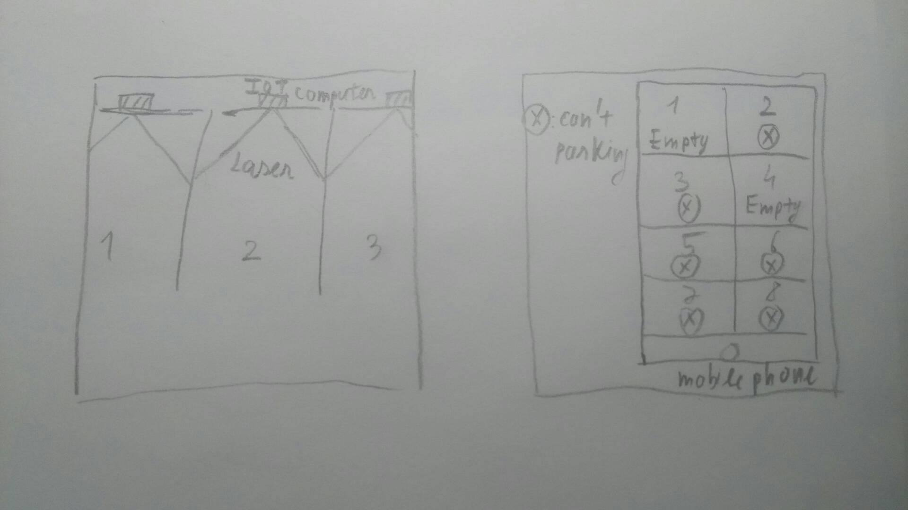

**Scenerio: Show user information about historical places**

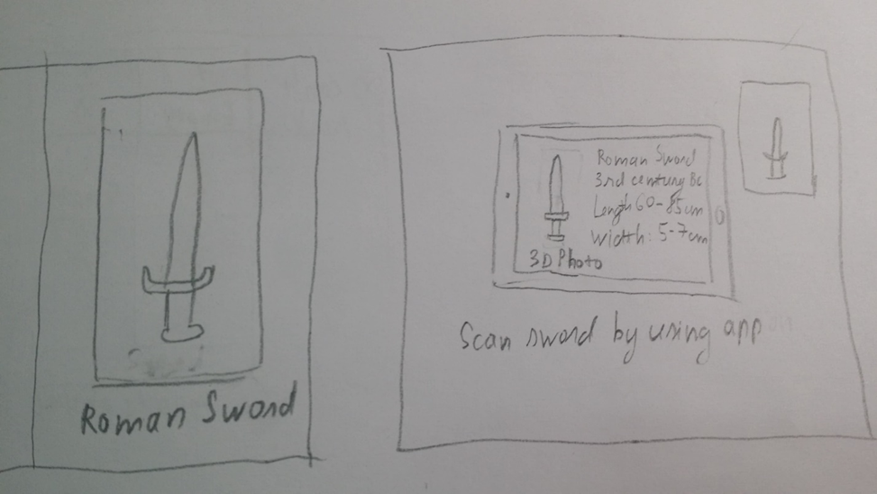

* + Describe the IoT, voice, VR, or AR system:

**App: Show user where they can park their car**

* + - sensors needed for the scenario, what are they sensing?

Sensor needed: Parking spot laser sensor can be position at each parking spot, most likely they will be on the ground on the road or in the wall near them. Laser Sensors are used for detecting presence based on position or light intensity. Parking Spot laser Sensor is a wireless parking sensor that allows real-time detection of the state of occupation of parking stalls

* + - analysis of the “automatic" processors, what they do

The laser sensor will automatic send some of its laser one time every second. These laser distance sensors use a light-speed, focused, coherent light to measure distance to a target object. If they hit anything inside of their accepted radius or don’t hit anything, they will automatically send data to cloud database and then back to the app real-time thanks to wireless internet environment at their parking location. The delay between those result is nearly zero. The result of the laser when call back determine the presence of the vehicle on the stall.

* + - the output or action the system takes, is there important feedback needed?

After the app receive data, app will update the data real-time according to how the data it received. User can choose to look for parking spot for themselves or turn on automatic guide feature which is voice instruction to navigate them to the nearest parking spot so users can then see if there’s any empty spot in the selected location, so they can reduce the time it takes to find an empty spot without the app. The app also calculated the data it received, analyze per hour which parking spot often have spot taken and which don’t and predict the future which spot is most likely empty in certain amount of time. Therefore create convenient for user to use the app, and also create user habit of using their familiar parking spot.

**App: Show user information about historical places**

* + - sensors needed for the scenario, what are they sensing?

Sensor needed: Vr feature must be installed in user phone, A VR sensor used as a simple proximity sensor can determine the position of a mechanical link in a piece of industrial equipment.

* + - analysis of the “automatic" processors, what they do

When user point camera at desired object, Vr sensor automatic target the object infont of the camera, when a target feature is moved close to the sensor, the flux is at a maximum. When the target is further away, the flux drops off. The moving target results in a time-varying flux that induces a proportional voltage in the coil. Subsequent electronics are then used to massage this signal to get a digital waveform that can be more readily counted and timed. Then the data callback will be send to server to analyze and the result will be send to user phone.

* + - the output or action the system takes, is there important feedback needed?

After the app receive data, app will update the data real-time according to how the data it received. Data will show depend on user refernces like the re-create of that battle on specific spots, video or picture relate to it. User can vote for if the information is correct or not to further improve app quality and they also can share among their friend or even post it to social network.